For Immediate Release

HOPKINS PRINTING WINS BEST OF REGION
AND PEOPLE’S CHOICE AWARD

COLUMBUS, OHIO (February 1, 2013) – Last night, Hopkins Printing was recognized at the Print Excellence Awards Banquet sponsored by the Printing Industries of Ohio and Northern Kentucky. It was a great night for Hopkins, who brought home two major awards: the People’s Choice Award and the Best of Region award.

The People's Choice Award is determined by banquet attendees who are invited to view all the award winning pieces and cast a vote for the one that leaves the biggest impression on them. This year the People's Choice Award winner was the “Arkansas Children’s Hospital: 2011 Annual Report” designed by Conrad Phillips Vutech and printed by Hopkins Printing. It features a spot UV coated, die-cut cover wrap that opens to reveal a laser cut preview window to page one.

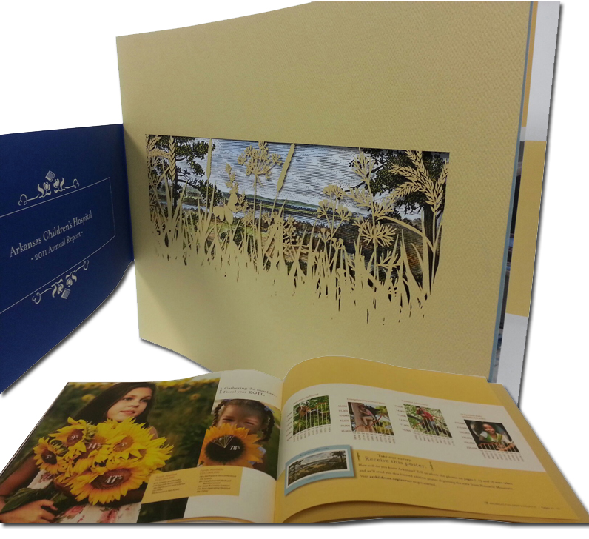
PIANKO also announced that the Print Excellence judges had awarded this same annual report a Best of Region award. Michelle Waterhouse commented on the achievement: "We are extremely proud that Conrad Phillips Vutech allowed us to produce this report. The Arkansas Children’s Hospital piece is stunning - a superb example of printing craftsmanship and worthy of these awards." Waterhouse is responsible for selecting projects to be entered into each of the annual contests for Hopkins Printing.

Hopkins Printing recognizes our award winning pieces on a special award wall in our plant. The next time you are in, take a minute to celebrate all the award winners we have produced for our customers.

About Hopkins Printing
Hopkins Printing is a 100% Employee Owned commercial printing company that has been in business for over 35 years. A graphics communications leader in the central Ohio area, Hopkins has been named A Best Workplace in America by Printing Industry of America and has received the Better Business Bureau Integrity Award. Hopkins was named a Top Small Company Workplace by Winning Workplaces in 2011 and was featured in Inc. Magazine for its innovative cross-training program.

# # #

For more information, please contact:
Roy Waterhouse
Hopkins Printing
614.509.1080
rwaterhouse@hopkinsprinting.com

