What’s New At Hopkins

May, 2004

Contact:
Roy Waterhouse
(614) 509-1080

Hopkins Printing is on the move again. We have installed the latest technology in the area of automated folding - the MBO Navigator. This is a full-size folder with a computerized set up. Instead of setting up the folder manually, the operator tells the computer what type of fold and the computer, with small electronics, sets up the folder. A 45-minute set up can now be done much quicker - saving you time and money.

This is another step in our journey to having a "Smart Factory." With the intelligent front end, you can see our philosophy of investing in the future in order to remain a strong supplier for decades to come.

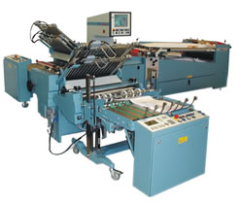
This is part of a larger strategy that will allow us to take electronic data at the beginning of a project and use that to set up prepress layouts, inking and feeder setups on press, cutting, folding and stitcher setups and finally to package and produce shipping paperwork that is accurate.

To find out more about how Hopkins Printing can be of better service to you, please contact Roy Waterhouse at 614.509.1080.

###

