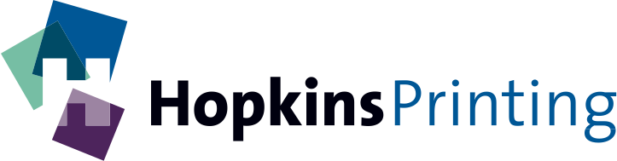
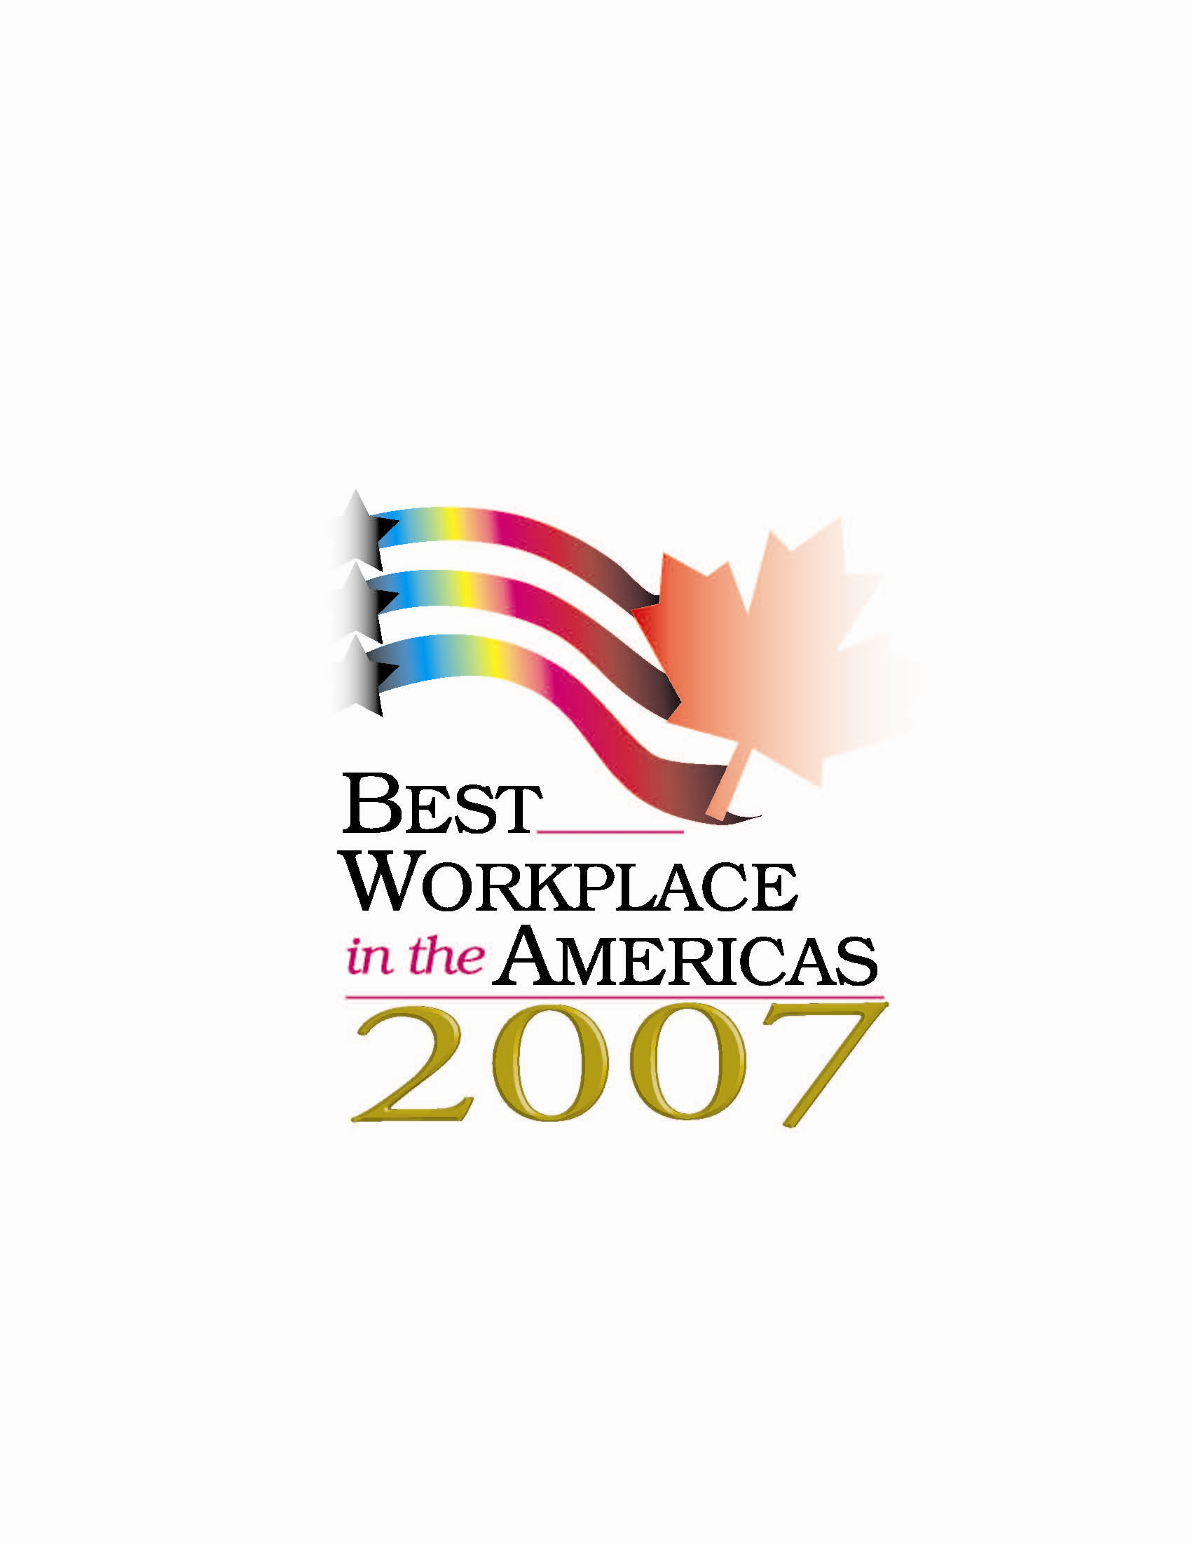
FOR IMMEDIATE RELEASE Jan. 15, 2008
Contact: ROY WATERHOUSE
Hopkins Printing
(614) 509-1080

Hopkins Printing named Best Workplace in the Americas

COLUMBUS, Ohio – Hopkins Printing recently was named a Best Workplace in the Americas in 2007 for its high level of human resources practices. This year marks the eighth year of the Best Workplace in the Americas program, which honors printing companies that provide a superior work environment.

“It’s an honor to be recognized by the industry as a company that offers a superior workplace,” said Jim Hopkins, president and CEO of Hopkins Printing. “Being a 100 percent employee-owned company gives us a unique perspective on the value of each and every person on our team.”

The award, which is given by the Printing Industries of America/Graphic Arts Technical Foundation (PIA/GATF), is chosen by a panel of highly respected HR professionals with decades of experience in the graphic arts industry. All of the winning companies actively demonstrate to employees that they care about their work environment, their personal goals and ambitions, as well as the needs of the company.

Applicants must meet the following criteria:
- Management practices
- Work environment
- Training and development opportunities
- Financial security
- Workplace health and safety
- Work-Life balance
- Recognition and rewards
- Health and wellness programs

“Best Workplace in the Americas winners routinely recognizes that success is generated in many ways, and importantly, through their employees. Congratulations to Hopkins Printing,” said president and CEO of Printing Industry of America/GATF, Michael Makin.

Headquartered in Sewickley, Pa., PIA/GATF is the world's largest graphic arts trade association representing the industry with over 1 million employees.

About Hopkins Printing
Hopkins Printing is a leading high quality sheet-fed commercial printer in Central Ohio with over $17 million in annual sales. Hopkins Printing is a 100 percent employee-owned company that has been in business for over 29 years. The company has been named Best Workplace in Americas by Printing Industry of America, as well as received the Better Business Bureau Integrity Award.

###

